Julian Kelly & Kieran Lewis

Dagon’s Harbour

Level Design Document

Contents

Foreword 2

Project Goals 2

Idea 2

Software Requirements 3

Settings, Theme, and Location 3

Environment Setting 3

Key Locations 3

Theme 4

Project Purpose 4

We Want to Create… 4

We Want the Player to Experience… 4

Features 5

Gameplay Reference and Research 6

Photo Reference and Research 8

Photo Reference 8

Architecture Reference 8

Environment Reference 12

Lighting Reference 13

Prop Reference 14

Inspiration Reference 15

Research 24

Story 25

How? 26

Why? 27

What? 27

Show, Don’t Tell 27

Set Pieces 27

Level Design/Stand Alone Game Environment 28

Set Pieces Within the Game Environment 28

Focal Points 28

Colour Palette 29

Lighting 29

Top Down Layout 30

Project Planning 36

Production List 36

Prop/Asset List 37

Audio Assets 38

Playtesting Strategy 39

References 40

# Foreword

For the purposes of brevity and ease of use, this document will use a Harvard Referencing scheme for text references to scholarly works only, all other references will be hyperlinks.

We will be providing direct links to web sources in the case of images and 3rd party middleware and asset vendors.

# Project Goals

* To create a playable 3D level using the Unity engine at a professional level, as per the module brief
* Improving our level design skills along the way
* Practicing the physical construction of a playable level
* Implement version control and facilitate file sharing through the use of a Github repository (<https://github.com/OutOfTimeDevelopment/FishingVillageLevel>) and Google Drive

# Idea

Dagon’s Harbor is a first-person horror game where the player is completely helpless in a desolate fishing village in the Mediterranean. Our character Matthew Blake has arrived in a village he has never seen before and must escape from the village.

The player will have to explore and find items in order to reach the other areas of the game, some puzzles per se will have to be completed in order for the player to escape all whilst enemies that cannot be killed are roaming around. The reason for this is that Matthew isn’t just fighting a random horror villain, he is trying to escape the Dagon’s army and Dagon is a god which could easily destroy a human like our main character.

The environment will tell the story of this desolate fishing village as no notes have been left from any previous occupants.

# Software Requirements

We will be using Unity 2018.3.2f1, this is because the two of us have used Unity in the past and we are more proficient using it rather than say, Unreal Engine. We will also be staying on that version of Unity throughout development so that there aren’t any issues when opening the project on each other’s PCs.

For development of any assets we need for the game we will be using Autodesk Maya student edition due to being able to use this for free and having learned a lot of it in a previous class at UWS.

Our project plan will be created using Microsoft Project due to it being good in the past for the creation of project plans. Any other documents will be authored using Microsoft Word.

# Settings, Theme, and Location

# Environment Setting

Dagon’s Harbor takes place in a fishing village in the Mediterranean. The village is somewhere on the Mediterranean coast.

The environment will be desolate and eerie looking with fish barrels and general clutter blocking the nearby roads and with fog emerging from the ocean. In this village there will be nearby houses along with a church that is in the town and an inn that has no occupants. The entire village has no inhabitants as if time has been frozen in place.

The atmosphere will become drearier when the player is exiting the inn as the sun will have set and there will be fog present.

# Key Locations

The level will have three key locations, this first is the Inn that the player must get to when they arrive and the second is the temple/church, the third being the harbor/beach. The temple/church is the largest building in the fishing village and the one that may hold the most answers.

Within the Inn, the player will find a key to the Church allowing them to then get into it.

The harbor/beach is the final area that the player must get to as it is where the items they found previously will be used for escaping.

# Theme

“Ancient fish gods ruin everything”. The theme of Dagon’s Harbor is curiosity, dread and solitude. This is due to the harbor lacking life and there being no hope for the main character in this harbor due to the impending doom that is spiraling around the harbor.

The player faces solitude throughout the whole game due to there being no one around him to help him and he must face everything head first alone without any guide. Our protagonist, Matthew Blake is curious and wants to keep exploring to find what has exactly happened to this village.

# Project Purpose

# We Want to Create…

A horror level where the player is helpless against a god and their antics. The player cannot obtain weapons as they would be useless due to the Dagon’s army of monsters being too dangerous to even try and fight. We want a game where the player has to explore and complete some small puzzles in order to proceed through each area of the game, we also want the player to understand just how desolate and dangerous this village is instead of seeing it as a nice Mediterranean getaway.

# We Want the Player to Experience…

Existential dread, sorrow and horror as they explore the eerie village. By this we mean that the player will begin to understand what is happening in the village and why the character is there in the first place and what has taken place. Through this is where the player will experience the sorrow of the village. The horror is in the village being desolate all whilst mysterious shadow figures emerge from the ocean as the fog engulfs the town.

The player will experience helplessness as they cannot fight back against anything and can only keep moving in order to escape from this horror. With the idea of the player not being able to fight back this allows them to soak up the experience of the village by looking around at everything whilst they walk about exploring and finding out where they need to be and what they need to do.

# Features

* A 3D scene (or set of scenes) developed using Unity 2018.3.2f1 (64-bit)
* A player character, rendered from a first-person viewpoint, with the ability to move (no jumping), look around, but with limited interaction with the environment.
* An inventory displaying player items
* Scene0 - A Main Menu which will allow the player to choose to start a new game, continue their old one, view help for the game or exit the game.
* Scene1 – The main playable level situated in a Mediterranean fishing village (lit as if by late afternoon sunshine) with a limited number of unblocked routes through the streets from bus top to boarding house/inn.
* Scene2 – The same level geometry lit as if at dusk with a limited number of unblocked routes through the streets from boarding house/inn to temple/church.
* Scene3 – The same level geometry lit as if by a moonlit night with a limited number of unblocked routes from temple/church to the harbor/beach at low tide. The beach contains ancient stonework and a portal to end the level.

# Gameplay Reference and Research



Playable Teaser was a game demo developed by Konami but never seen a full release. This is a video showcasing a walkthrough with the horror elements in the game.

The game is quite tense as you never really know what is going to happen as you keep moving along the path. This is something we want to communicate with our level, you never know if you truly are in danger as you move along the new paths that have been created



Dear Esther was one of the first “walking simulators”, where atmosphere, narrative, and experience are more important than gameplay and moment-to-moment excitement.



What Remains of Edith Finch is another game that we would seek to emulate. One of the modern “walking simulators” with more gamey elements but still with strong exploration and narrative telling properties.

# Photo Reference and Research

# Photo Reference

# Architecture Reference

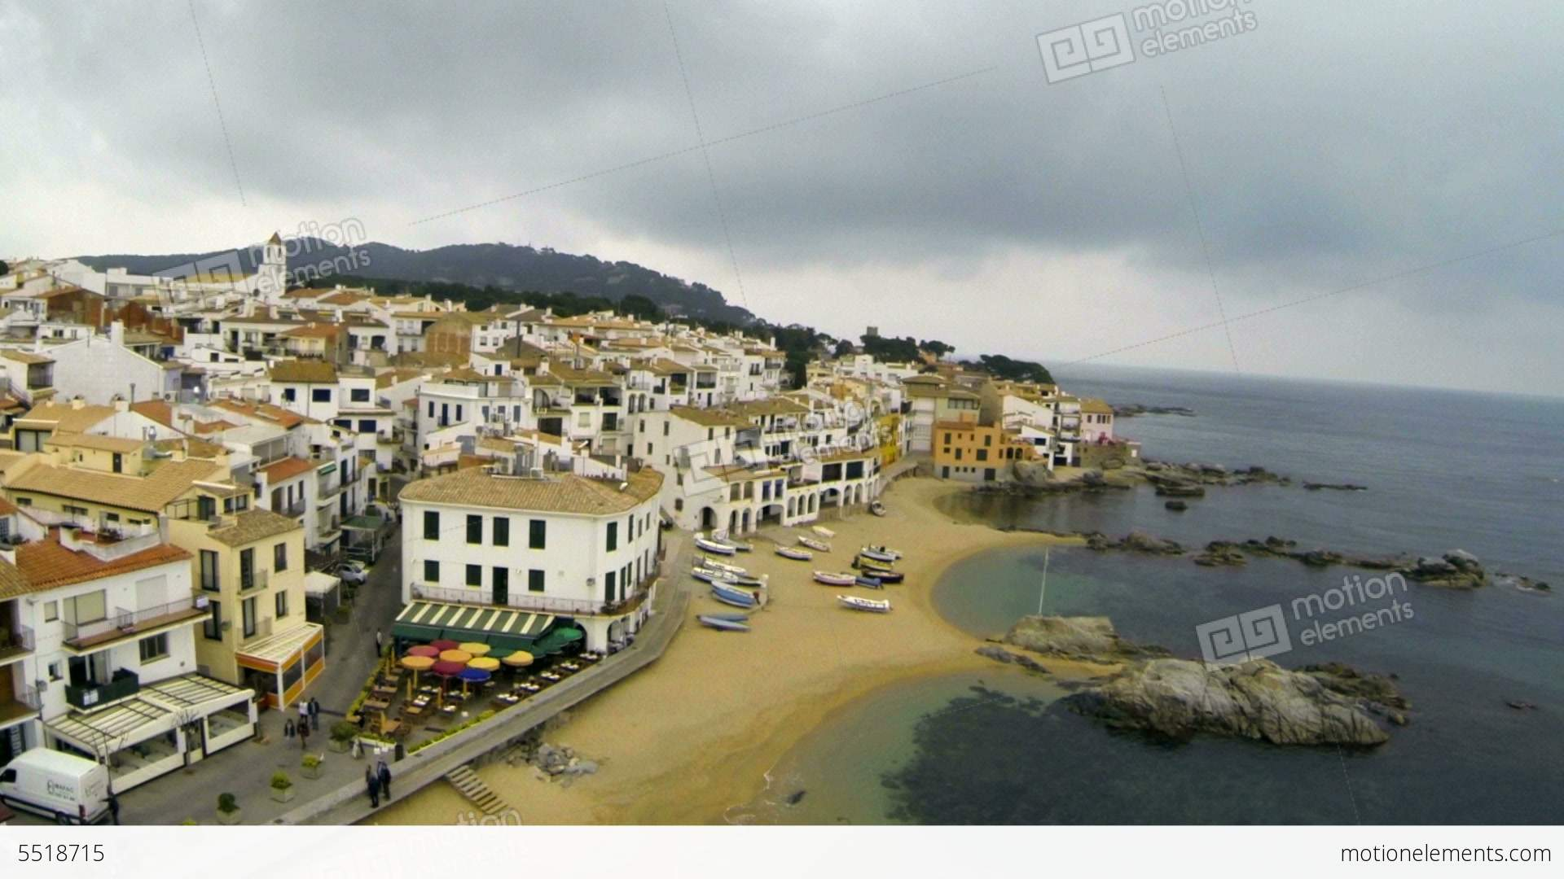

Figure 1 - Courtesy of <https://www.motionelements.com/stock-video-5518715-aerial-drone-view-mediterranean-fishing-village>

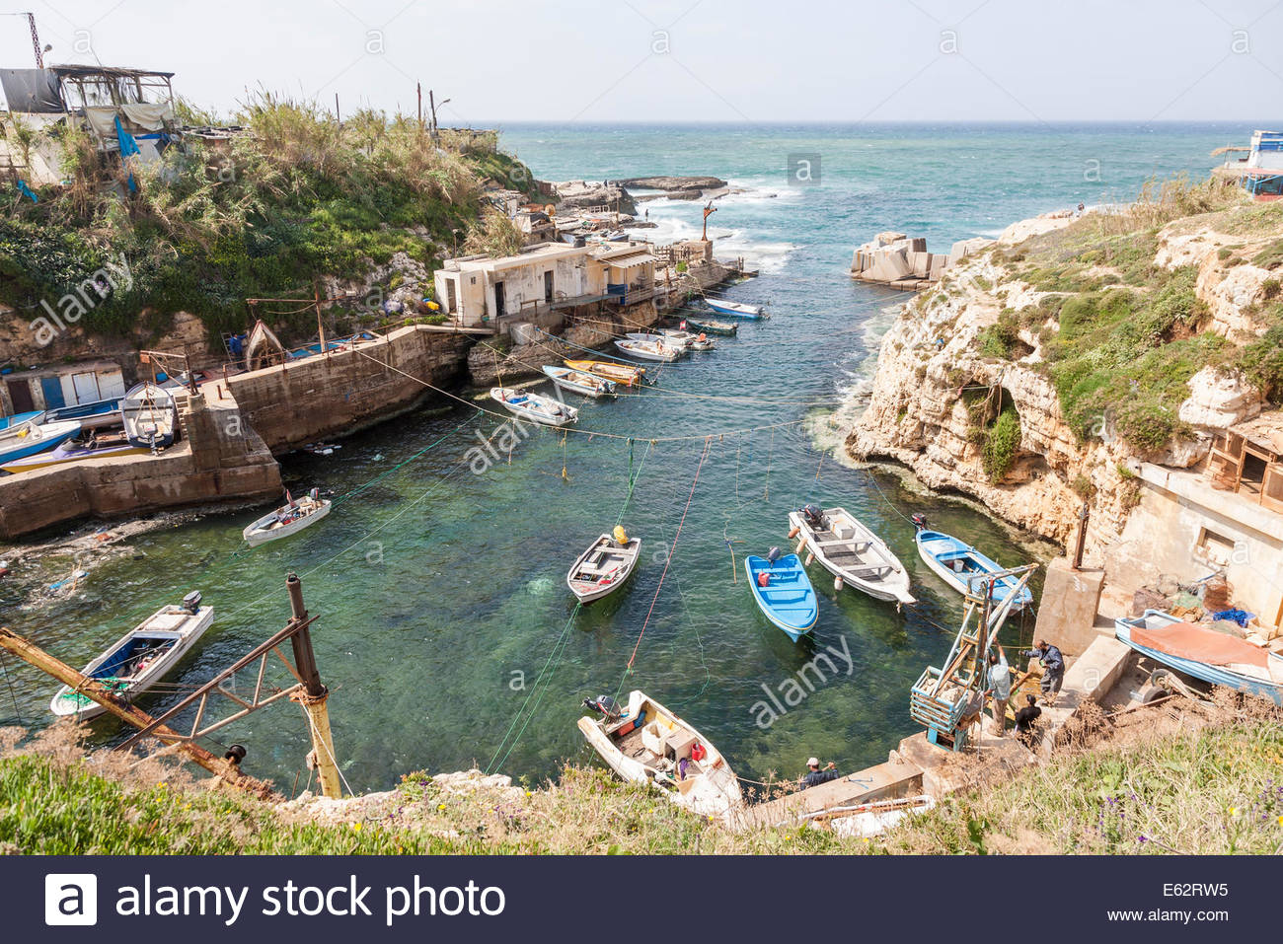

Figure 2 - Courtesy of <https://www.alamy.com/stock-photo-a-small-fishing-village-community-and-harbour-on-the-mediterranean-72592049.html>

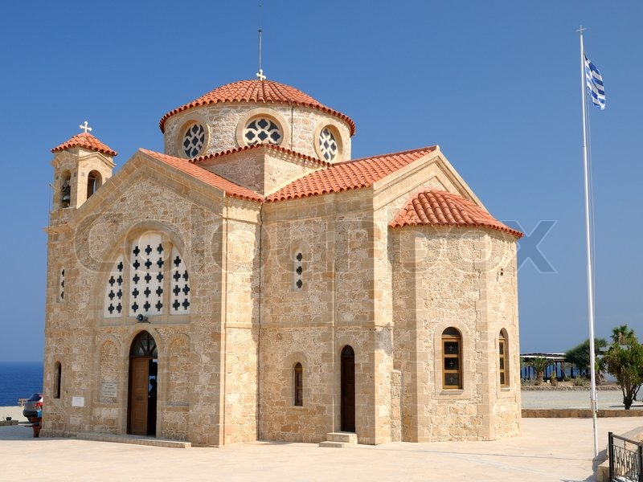

Figure 3 - Courtesy of <https://www.colourbox.com/image/church-of-st-george-on-mediterranean-sea-coast-near-of-paphos-republic-of-cyprus-image-4597046>

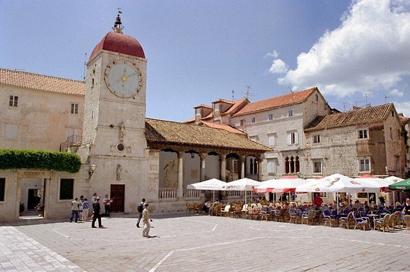

Figure 4 - Courtesy of <http://www.taxi-zadar.biz/transfers/touristic-trours-and-excursions/>

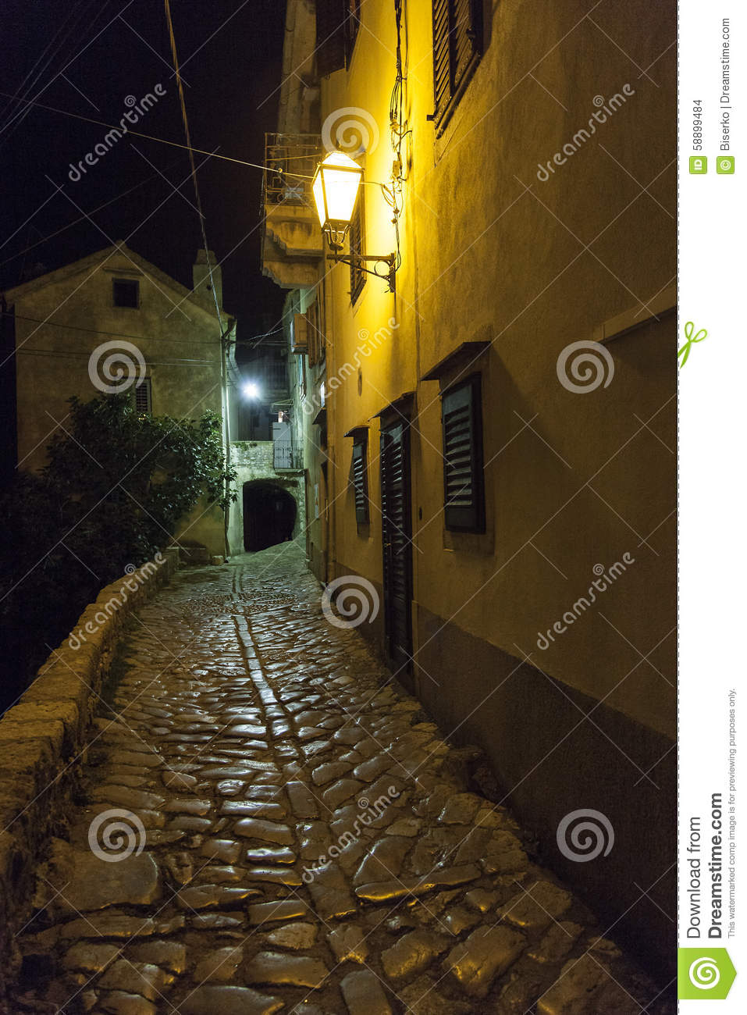

Figure 5 - Courtesy of <https://www.dreamstime.com/stock-photo-ancient-street-small-mediterranean-village-traditional-stones-flooring-image58899484>

*Figure 6 - Courtesy of https://www.dreamstime.com/stock-photo-ancient-street-small-mediterranean-village-traditional-stones-flooring-image58899484*

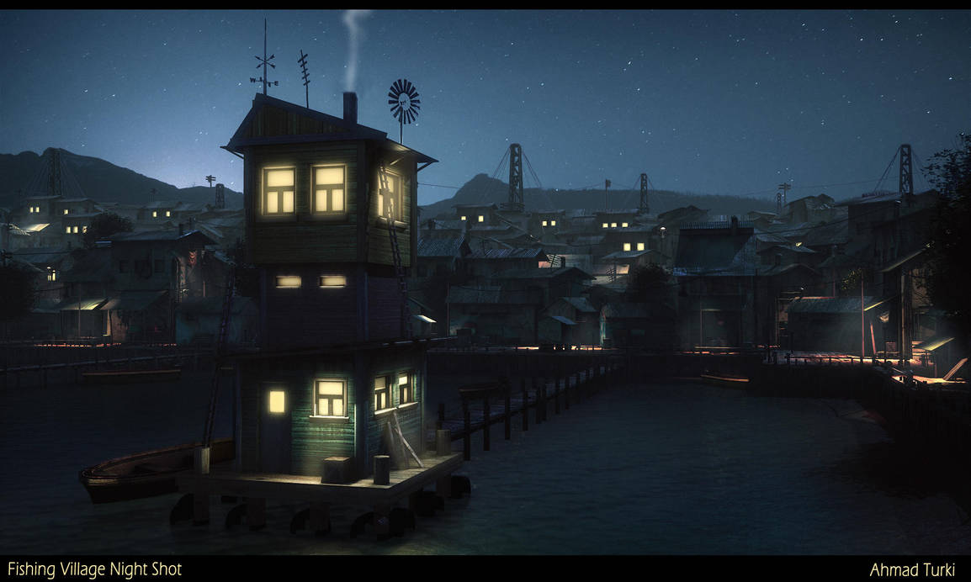

Figure 7 - Courtesy of <https://www.deviantart.com/ahmadturk/art/Fishing-Village-Night-Shot-397381355>

# Environment Reference

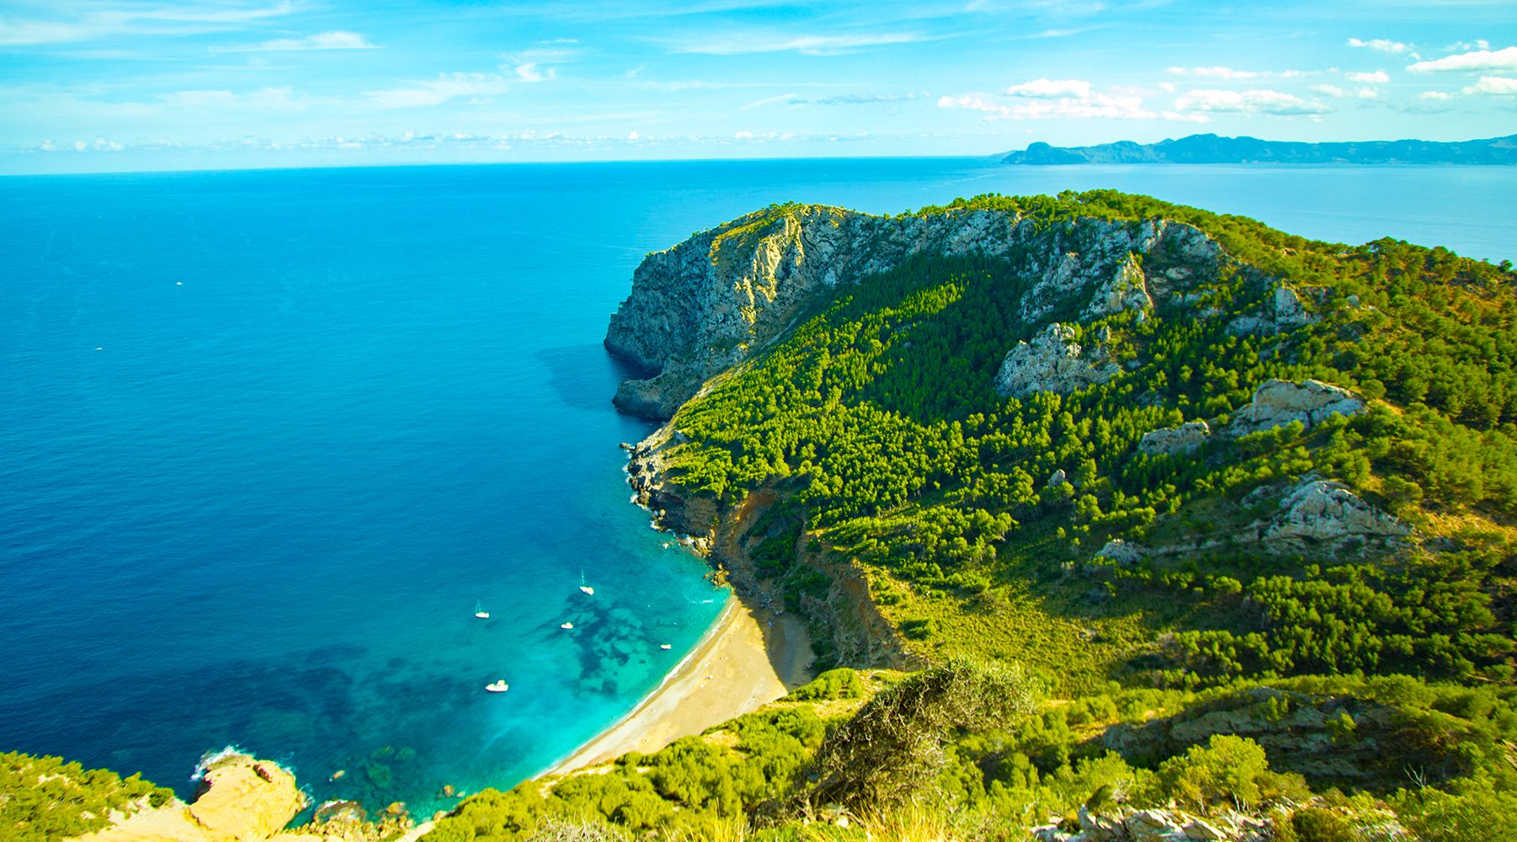

Figure 8 - Portuguese Coastline image courtesy of <https://www.azamaraclubcruises.co.uk/voyage/jr09m144/9-night-mediterranean-islands-voyage>

# Lighting Reference

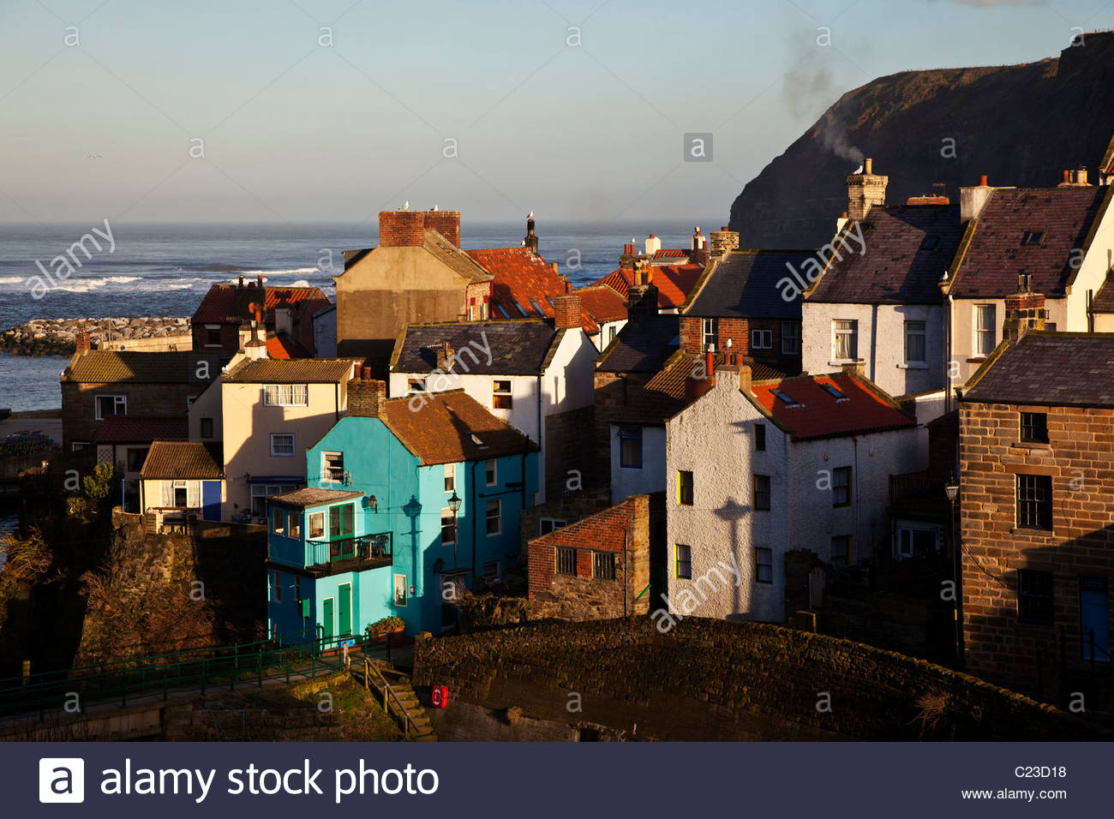

Figure 9 - Late afternoon sun shines on Staithes, a North Yorkshire fishing village, courtesy of <https://www.alamy.com/stock-photo/late-afternoon-sea-with-sun.html>

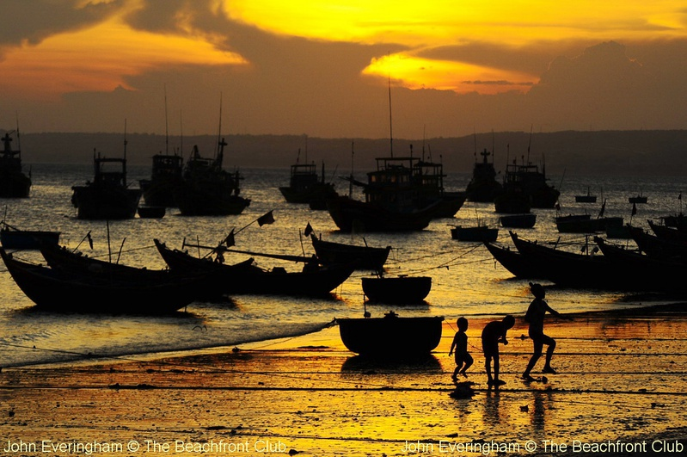

Figure 10 - Mui Ne Beach, Vietnam at twilight courtesy of <http://true-beachfront.com/guide/mui-ne-beach-vietnam-fishing-village-a-traditional-boats>

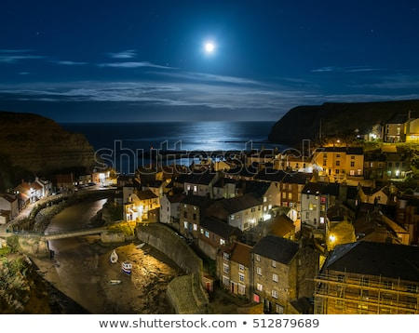

Figure 11 - Staithes by moonlight, courtesy of <https://www.shutterstock.com/image-photo/picturesque-fishing-village-staithes-by-moonlight-512879689>

# Prop Reference



Figure 12 - Courtesy of <https://www.canstockphoto.co.uk/harbour-6-0586884.html>

It is envisaged that most small props relevant to a fishing village will be found in the various asset collections used by the project. Simple clutter will be provided by barrels, carts, and other static meshes in keeping with the theme.

Anything we can’t find, we make.

# Inspiration Reference

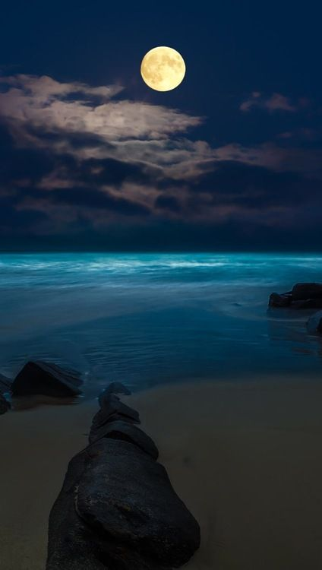

Figure 13 - Courtesy of <https://www.pinterest.co.uk/pin/195906652515030147/>

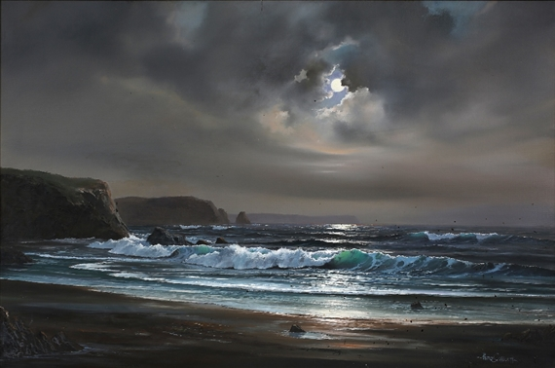

Figure 14 - Courtesy of <https://www.mutualart.com/Artwork/Moonlit-beach-scene/EA82D48731898F43>

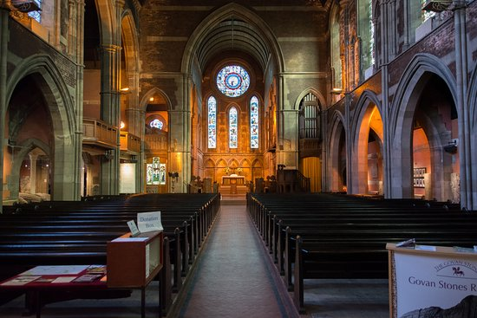

Figure 15 - Courtesy of <https://www.tripadvisor.com/LocationPhotoDirectLink-g186534-d214125-i310096169-Govan_Old_Parish_Church-Glasgow_Scotland.html>

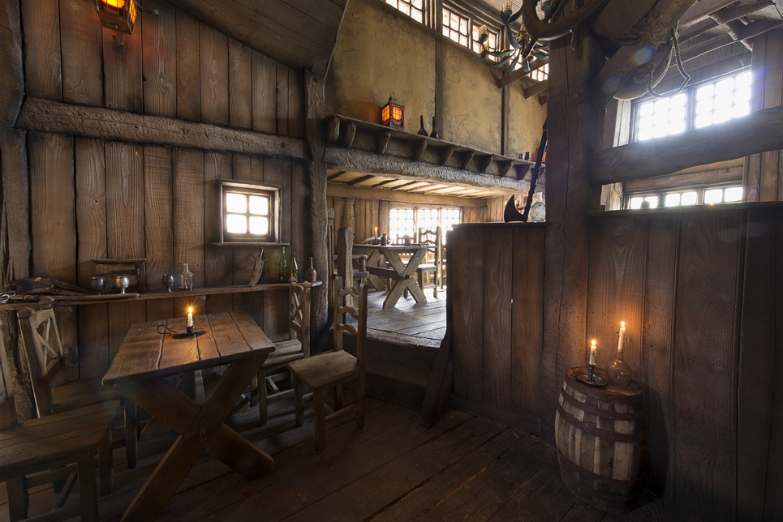

Figure 16 - Courtesy of <https://homedesignersuite.co/top-3d-home-designer-for-your-perfect-home-design-project/>

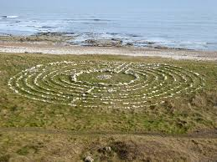

Figure 17 - Courtesy of <https://www.geograph.org.uk/photo/4847636>

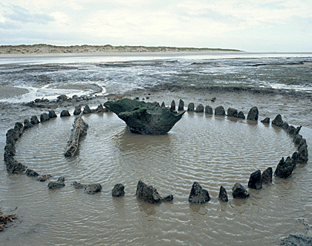

Figure 18 - Courtesy of <https://www.culture24.org.uk/history-and-heritage/archaeology/art489043-Archaeologists-ring-date-ritual-Bronze-Age-stone-circle-same-year-Norfolk-Seahenge-same-year-sister-site>

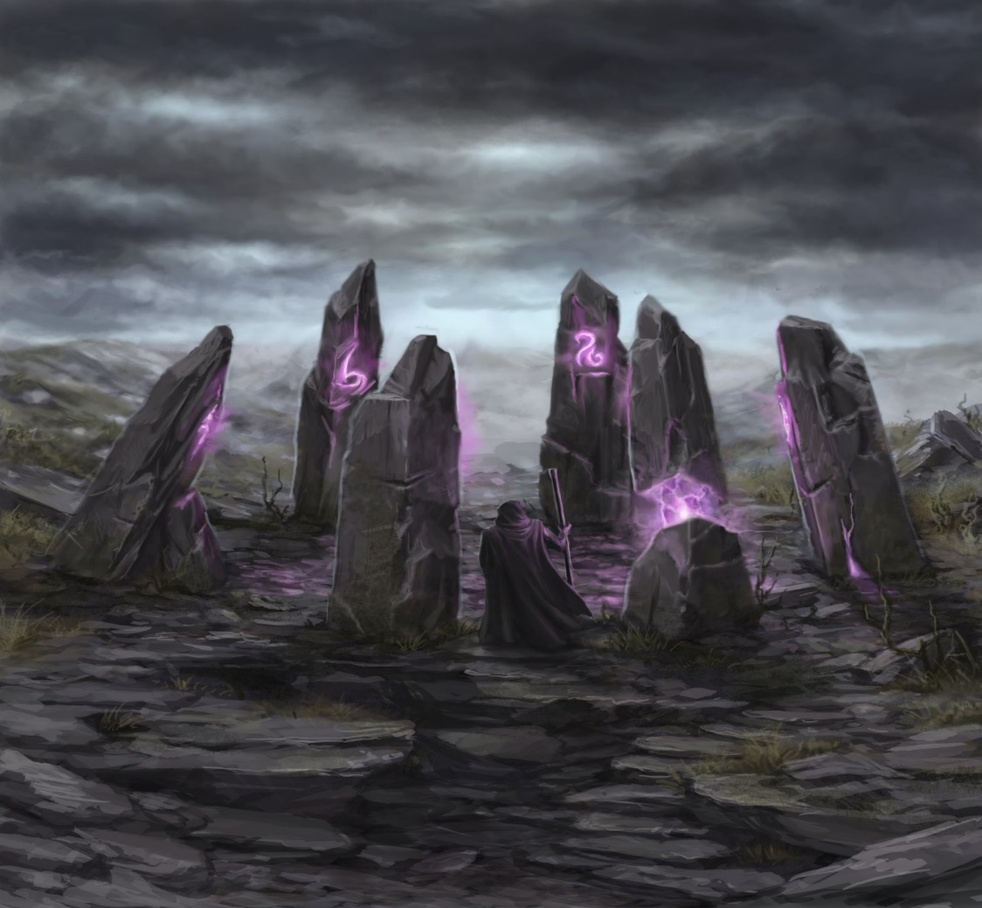

Figure 19 - Courtesy of <https://sventhor.artstation.com/projects/Pe4WL?album_id=11727>

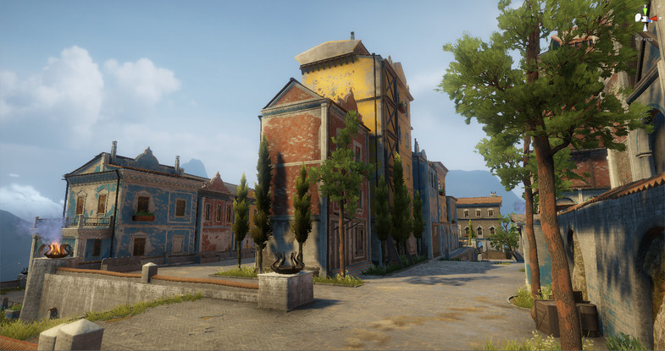

Figure 20 - Courtesy of <https://assetstore.unity.com/packages/3d/environments/sun-temple-115417>

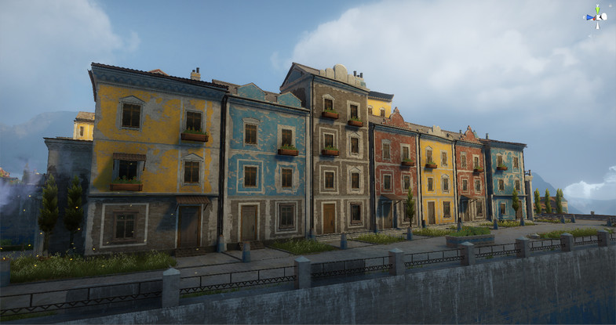

Figure 21 - Courtesy of <https://assetstore.unity.com/packages/3d/environments/sun-temple-115417>

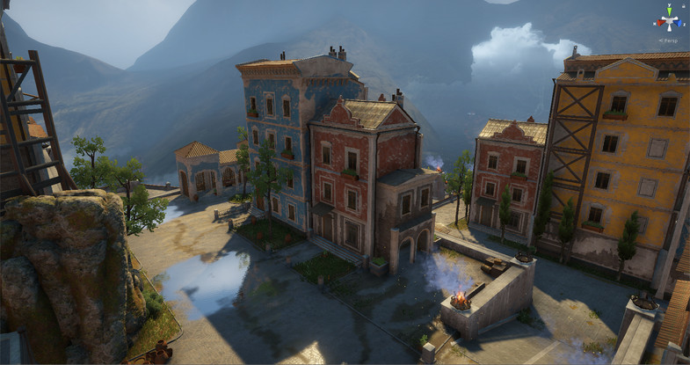

Figure 22 - Courtesy of <https://assetstore.unity.com/packages/3d/environments/sun-temple-115417>



Figure 23 - Courtesy of <https://www.imdb.com/title/tt0264508/>

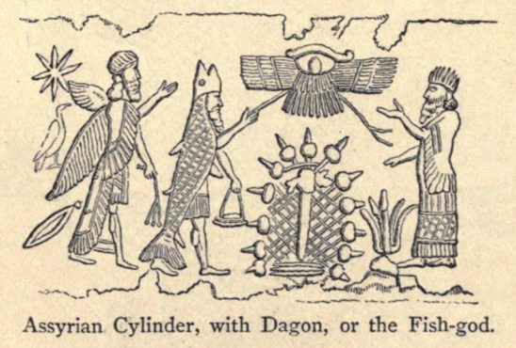

Figure 24 - Courtesy of <https://mythcreants.com/blog/lessons-from-the-vivid-writing-of-lovecrafts-dagon/>

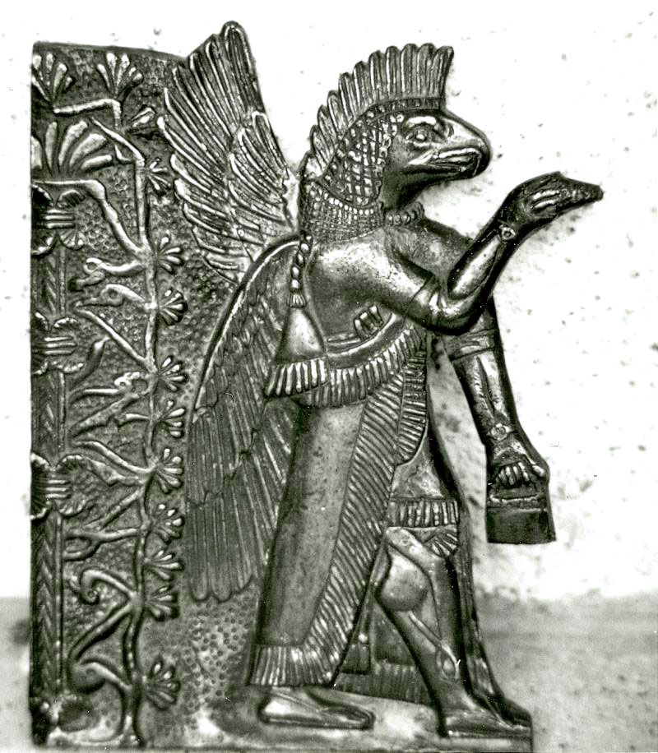

Figure 25 - Courtesy of <https://www.pinterest.co.uk/pin/467318898804419661/>

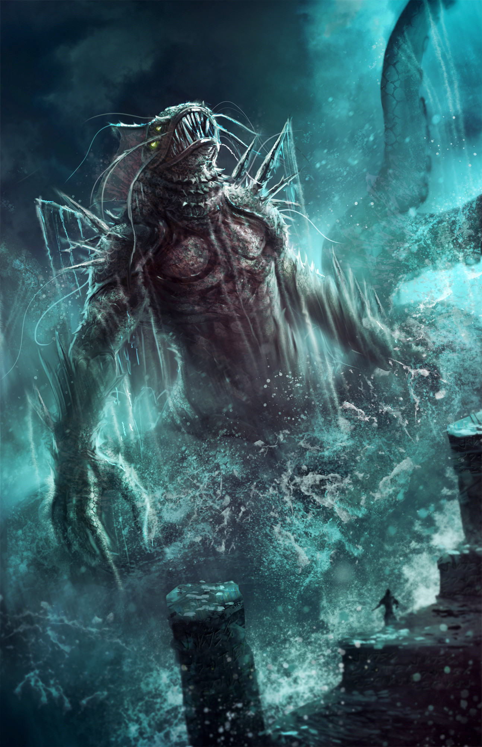

Figure 26 - Courtesy of <https://www.artstation.com/artwork/JRNlz>

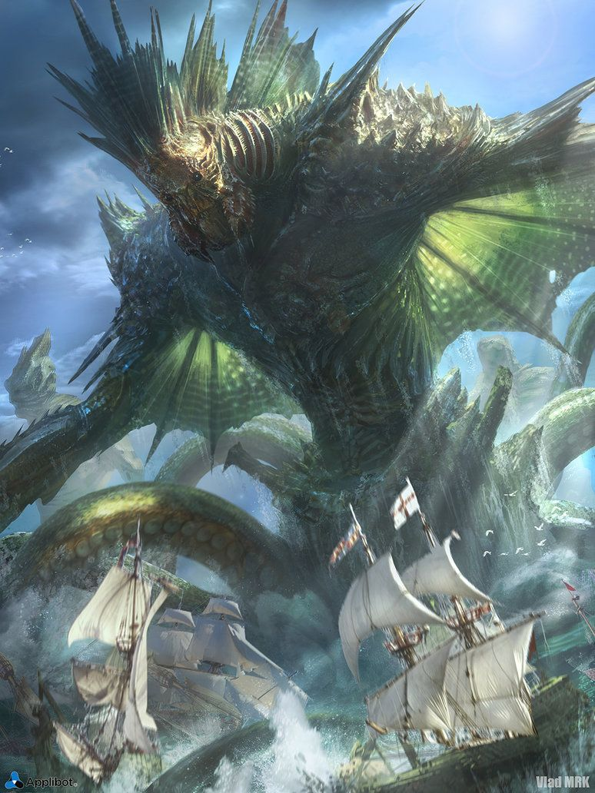

Figure 27 - Courtesy of <https://www.pinterest.co.uk/pin/412431278353989906/>

# Research

We have looked at multiple sources to get an exact idea on the type of level we want to make and the topology of the level we want to make. We have decided to make it a Horror level with linear aspects rather than nonlinear.

“Linear gameplay. Sometimes it can mean an excruciatingly simple and trudging story that you can do little to make fun. Other times, it can be one of the most thrilling experiences you can have playing any video game at all.” (Bui, 2010)

We don’t really want the level to be fun per se, we want the level to tell a story whilst the player follows through on a set path. Adding explosions, combat and tons of action would remove a lot of the soul that the game is trying to capture

“Even though you have to make a smaller area look good in games that keep you fenced in, they require a lot more work for a few different reasons. The main problems with linear levels are designing barriers that are convincing, making the difficulty consistent and keeping the player's attention.” (Serr, 2009)

We want to box the player in, we want them to feel claustrophobic in the level that we are making, having them go exploring could possibly ruin the story that we are trying to get over. This isn’t because the player needs to rush through with what they do but because the environment around them is telling them a story piece by piece and if the player got to explore everywhere then they wouldn’t be able to take in that what’s happening is happening in real time to the main character.

“Do not block the player with short fences or other obstacles that should be trivial to bypass.” (Pruett, 2013)

Paths in the game will be blocked for the player that they should not currently be able to move through. This will be with heavy equipment that 1 person couldn’t move on their own and that also gets over the idea that there are still multiple mysterious people here as these paths keep changing for the player.

# Story

The story of Dagon’s Harbor is that it is a fishing village in the Mediterranean that seems to be lost in time. The pretty town seems to be having a bad case of the ancient sea gods (Dagon in this case) and an army of fanatics/thralls. They have killed or enslaved all of the occupants of the village. It is unclear how long this has been going on, but environmental storytelling will suggest that this is a recent occurrence.

The game starts with our main character Matthew Blake having arrived in a fishing village for a holiday but upon arrival he begins to see that there is no one around the village. Matthew came here to visit old friends or family but upon realizing that there is no one here after leaving the bus, he decides to look around for clues.

Matthew must first get to the inn before the sun sets. Upon arrival at the inn, he finds that the place has been disturbed and that there are no occupants anywhere to be found inside. He finds a key that is labeled for the church in the village but as he goes to leave the sun has set and the sky is dark, he begins to see the fog is rising more from the sea. This is when he starts to make his way to the church.

Through his journey to the church he notices that the path he came has been closed off with boat accessories and barrels. A path to the church that wasn’t accessible earlier has also been opened, as if someone or something wants him to go there, he decides to continue to the church even if he might seem scared to do so. At this point he knows there is something lurking around the village but cannot understand how no life has actually bumped into him.

Upon entering the church, he begins to look around at the dreary atmosphere, had people come here to seek refuge? This is one of the questions he asks himself as there is fishing equipment blocking windows and doors and with pictures of items on a wall with the broad subtitle of beach portal items. Matthew must now find these items and take them to the beach.

As Matthew goes to leave the church, he notices that the moon is fully showing through the calm night sky. He also notices shadowy figures walking through the heavy fog, they are wandering slowly to beach where the portal is said to be. Matthew now makes his way to the beach with once again a new path opening for him with the previous one being blocked. The fog begins to start closing in more on the village. Once Matthew arrives at the beach he will step into the glowing portal summoned by ancient Dagon while fog engulfs the town.

# How?

Upon spawn the screen brightens from black to a Mediterranean fishing village scene. The player has arrived in Dagon’s Harbor by bus. This is intimated not shown via use of an appropriate vehicle engine sound effect and by spawning with a bus stop in the players’ view. Since the character doesn’t speak and there are no proper NPC’s in the game, it is never explained in any detail how the player got here, with the exception of the bus sound effect and bus stop.

It is assumed that Matthew Blake has decided to come here for a short vacation but this will probably not be explained to the player.

# Why?

The player is seemingly here on holiday/to visit however it is never fully explained, as a fully fleshed out narrative is outside of the scope of this project (everyone likes a little mystery too).

# What?

Upon first arrival nothing seems amiss with the charming town. Lit with the warm glow of late afternoon sun, this idyllic spot seems like just the place to spend a wine tasting and walking weekend.

While traversing scene1 and into scene2, and scene3 the player will notice upturned props, allowing the environment to do a little storytelling. This will also set a new path for the player to follow.

By the end of a playthrough it will become clear to the player that something as badly awry here. This will be directly shown to the player via a scripted sequence of the inhabitants shambling towards the harbor, fog effects, particle effects, and scene lighting.

# Show, Don’t Tell

The player will see that there is progressive damage to the village, this will be shown with barrels and other objects lying over paths that the player cannot explore. Throughout the scenes, these placements will change to show that there is something eerie still moving about the village

The player will find no signs of life as they traverse the environment. However, we will know that something is damaging the environment when the player sees the shadowy figures moving around in scene 2 of the game.

# Set Pieces

# Level Design/Stand Alone Game Environment

We want the player primarily to experience curiosity. We’re also going for a little unease thrown in on the side.

Where do I find the inn? Where’s the innkeeper and why is there a chair upturned? What’s going on with that temple? What on earth are those shadowy figures doing and where are they going? What is that strange alignment of standing stones down by the harbor?

What is going on in Dagon’s Harbor?

We want to take the player through a journey of our own way rather than the player going on their own journey. A linear path for the player to follow instead of open world is better for the story we want to showcase.

The level typology for Dagon’s Harbor will therefore be of a linear nature.

# Set Pieces Within the Game Environment

Set piece one – player transition from boarding house/inn to temple/church – significantly different lighting and the addition of light fog.

Set piece two – A scripted sequence showing dark, silhouetted figures appear in the now heavier fog. Outside the church/temple they move silently towards the beach/harbor.

Set piece three – Entry into the beach portal triggers a camera flyby of the village from bus stop to portal, achieved via Cinemachine middleware.

# Focal Points

* The inn (the players’ first port of call)
* The temple (a welcoming glow in the gloaming)
* The stones (what nightmares lie in the deep?)
* The Lighthouse out in the distance (visible from everywhere on the map, useful as a navigational aid)

# Colour Palette

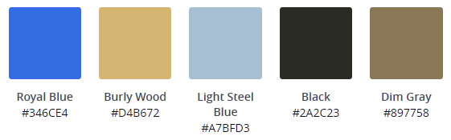

Figure 28 - Preliminary colour palette for daylight scenes



Figure 29 - An illustration of this colour palette in use

# Lighting

Lighting throughout the three levels will be quite different. The overall sky will be dulling but still bright as the sunset is happening when the player is making their way to the inn. After this, the sky will be darkened and some light from the moon will glare down upon the village. There will be candles that burn in the main areas that the player can explore for example, the church and the inn.

Once the player goes to the church the sky will darken once again and the moon will be much brighter in the sky. This will illuminate the environment even further.

# Top Down Layout

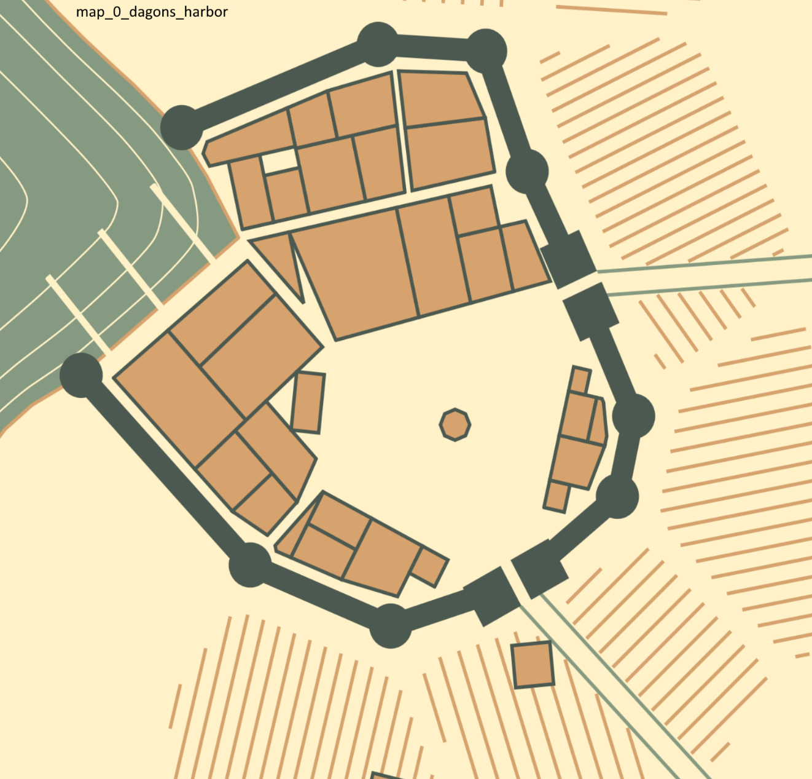

Figure 30 - Procedurally generated fishing village produced with the medieval fantasy city generator (<https://watabou.itch.io/medieval-fantasy-city-generator>)

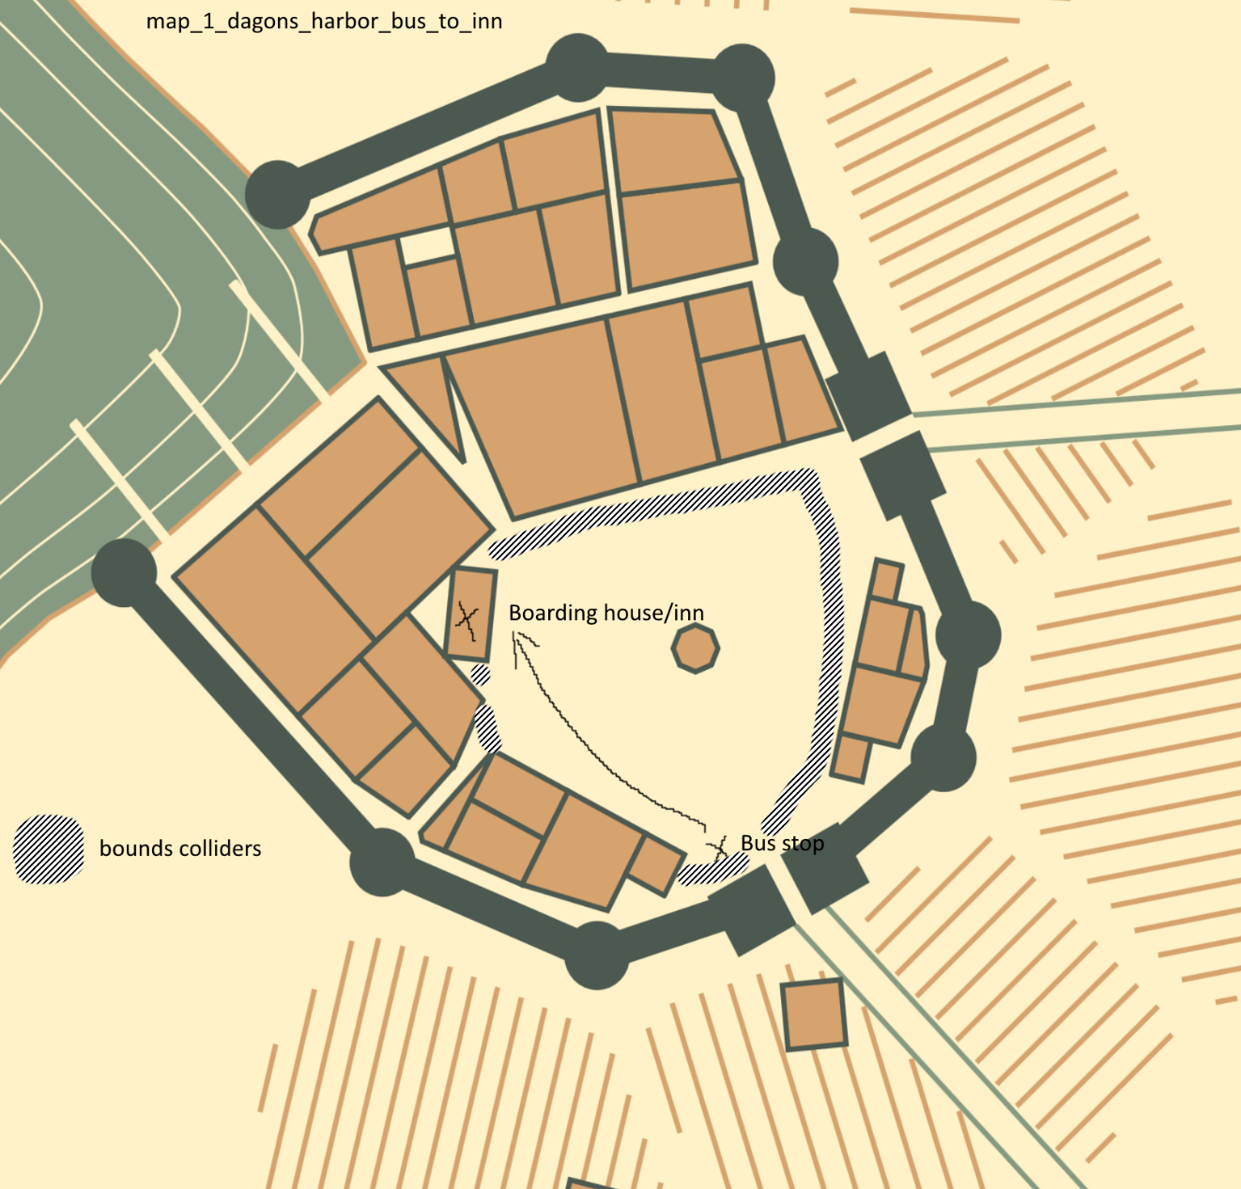

Figure 31 - map_1_dagons_harbor_bus_to_inn

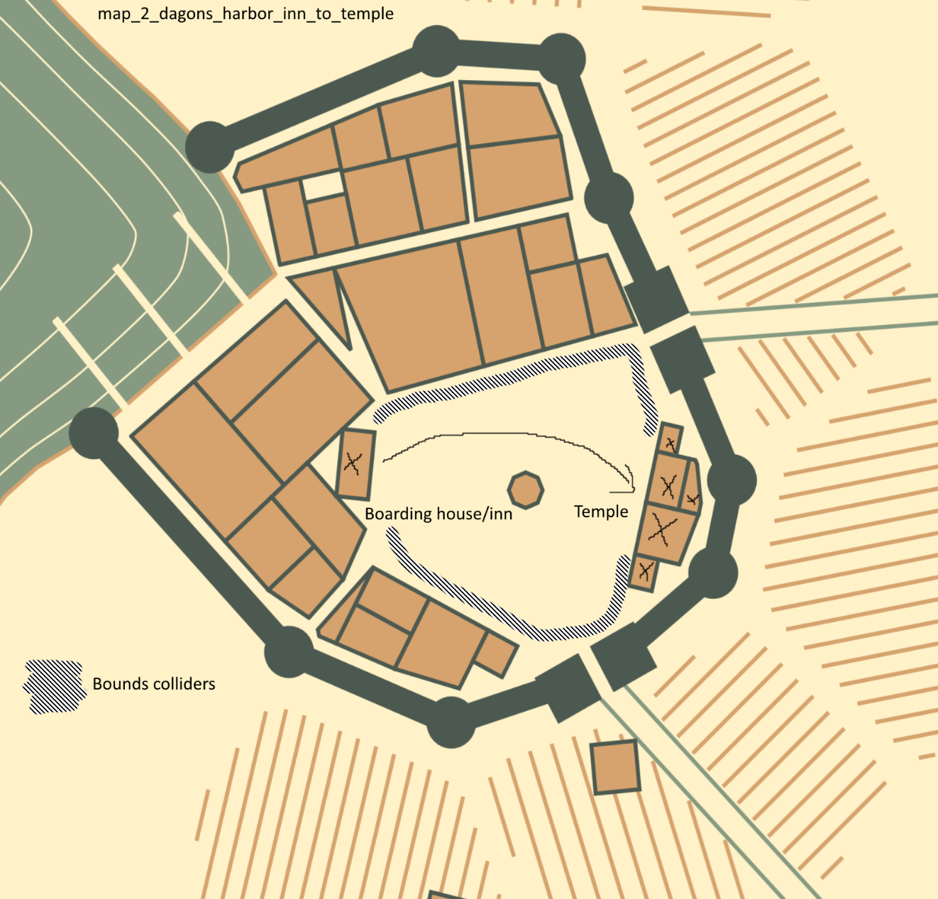

Figure 32 - map_2_dagons_harbor_inn_to_temple

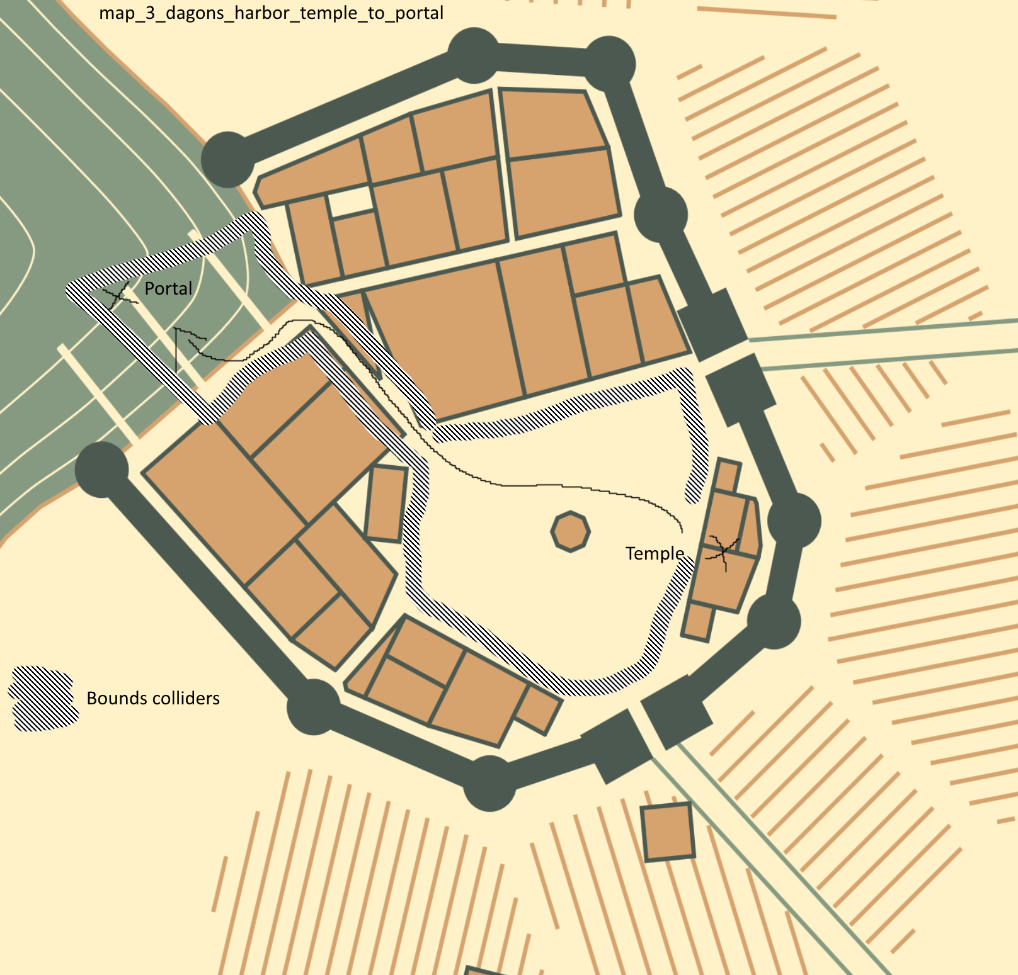

Figure 33 - map_3_dagons_harbor_temple_to_portal

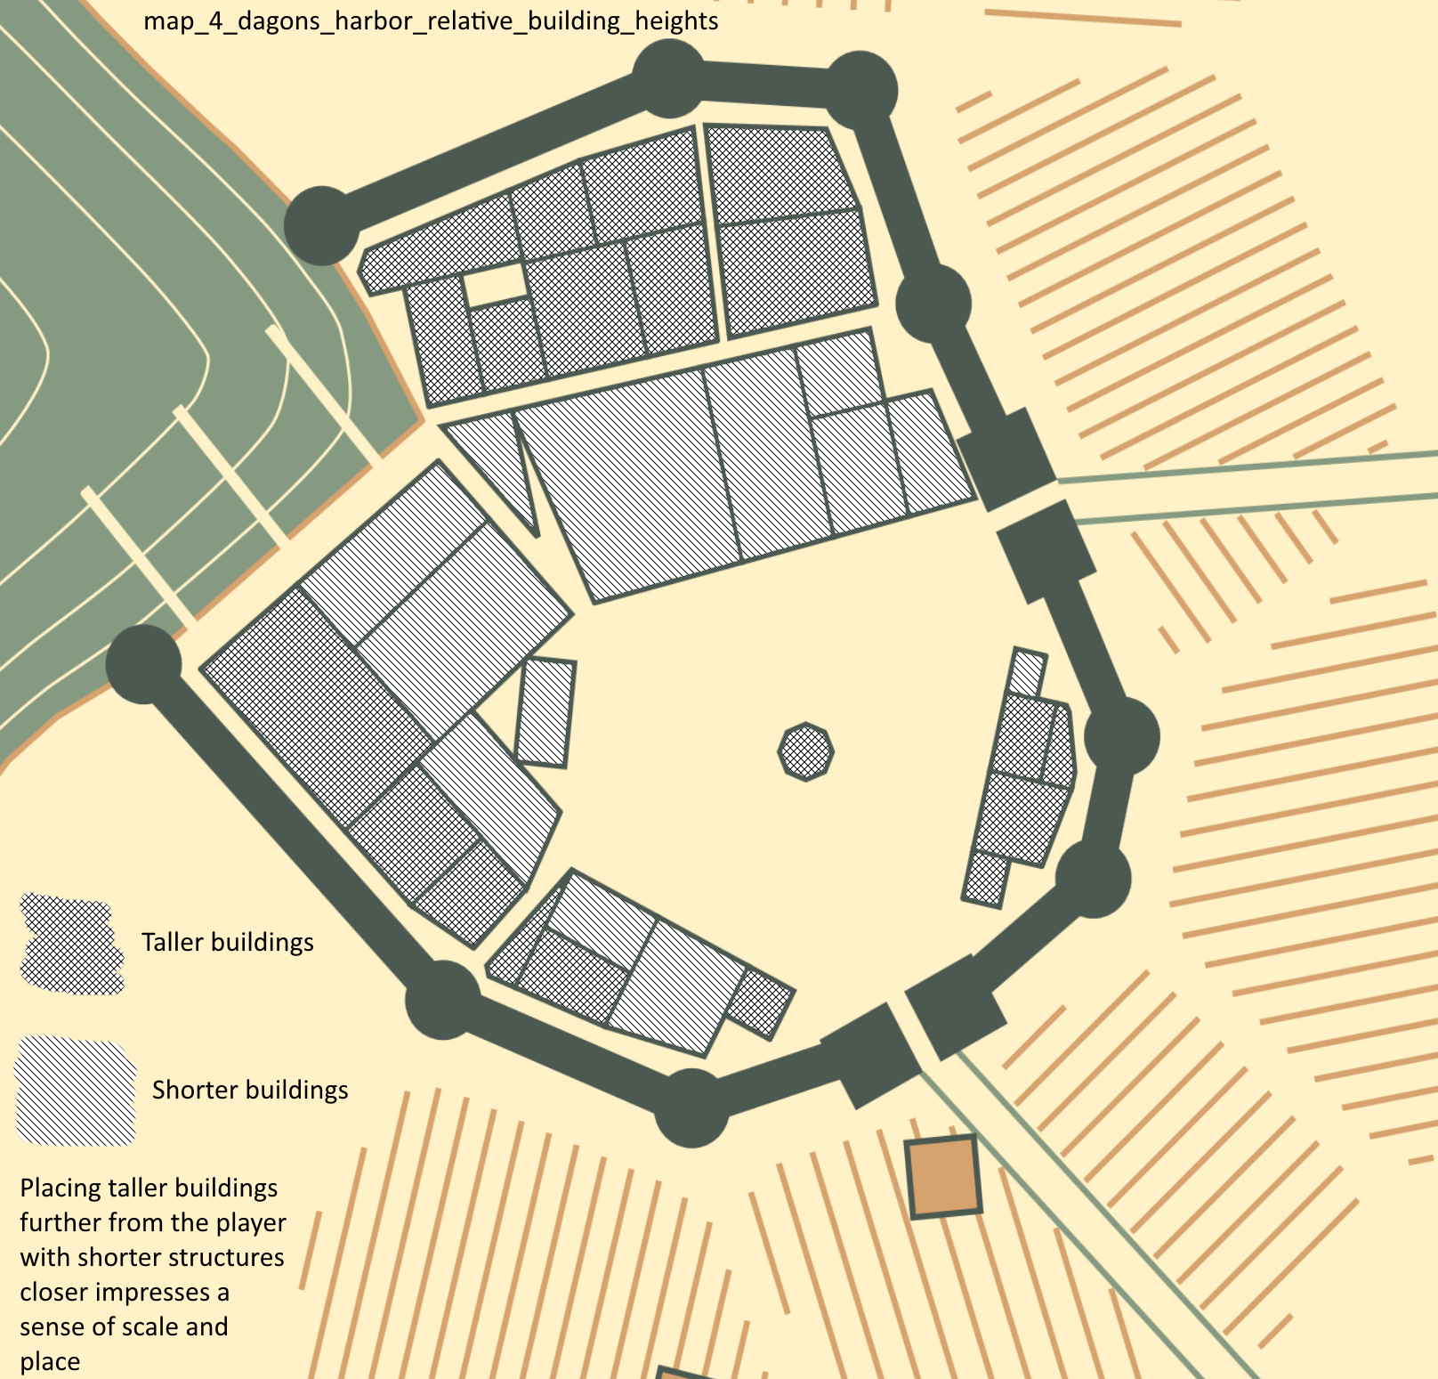

Figure 34 - map_4_dagons_harbor_relative_building_heights

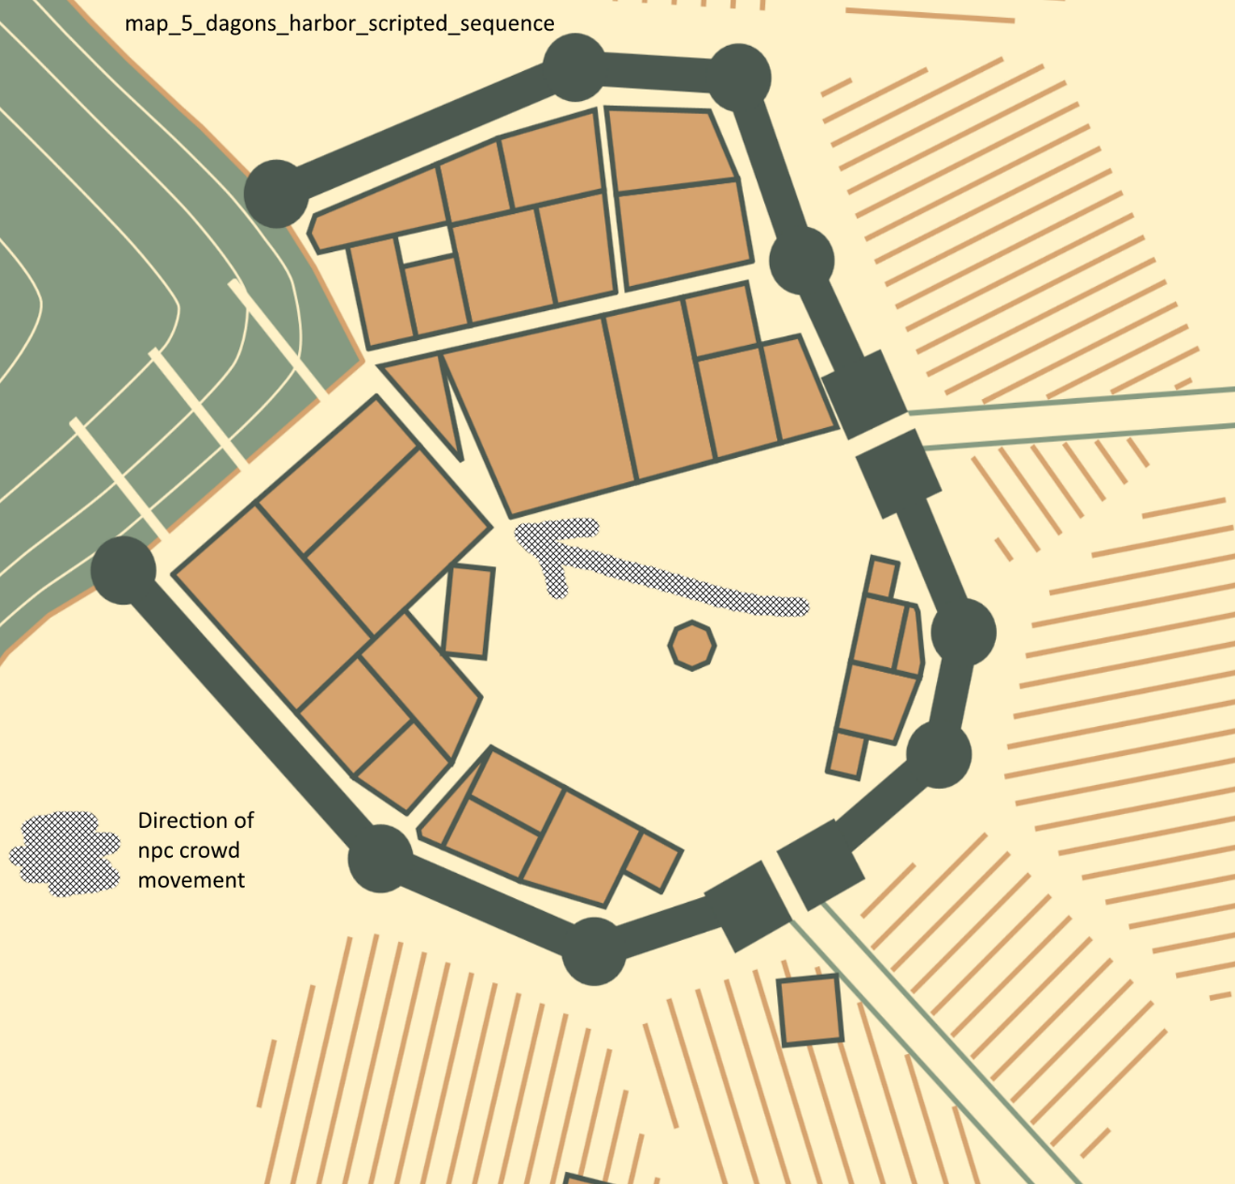

Figure 35 - map_5_dagons_harbor_scripted_sequence

# Project Planning

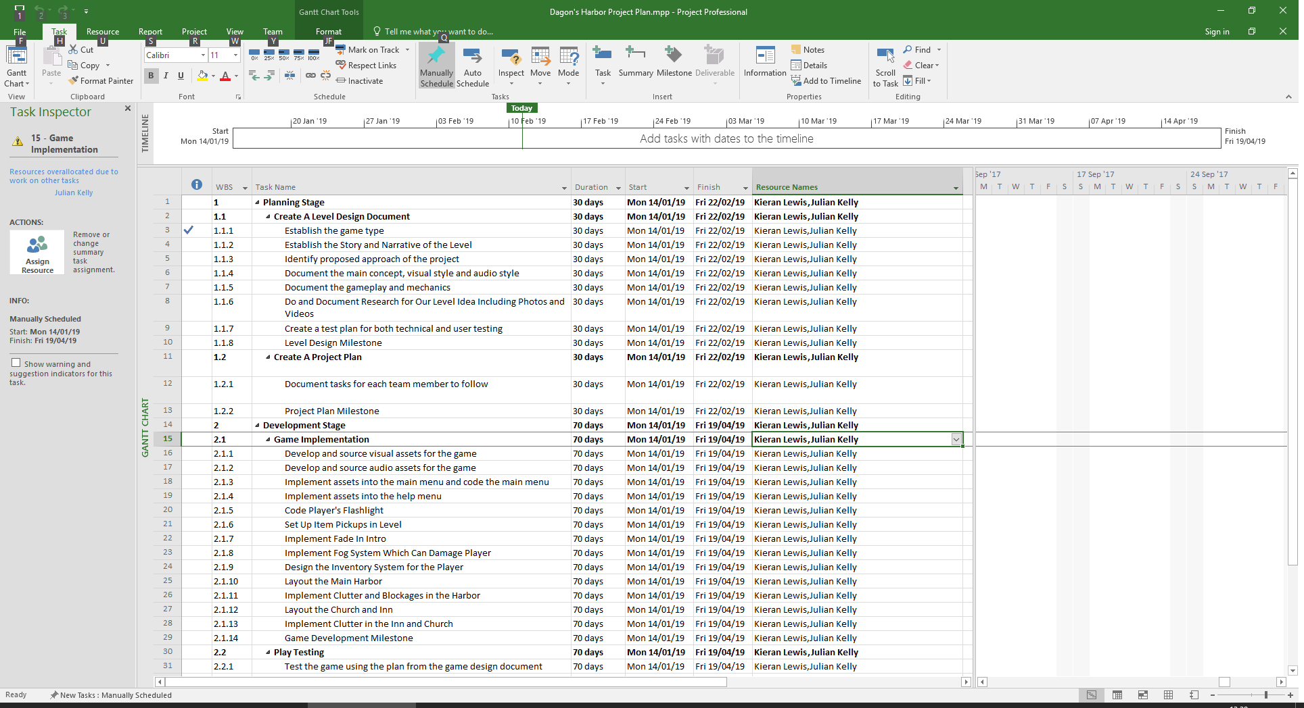

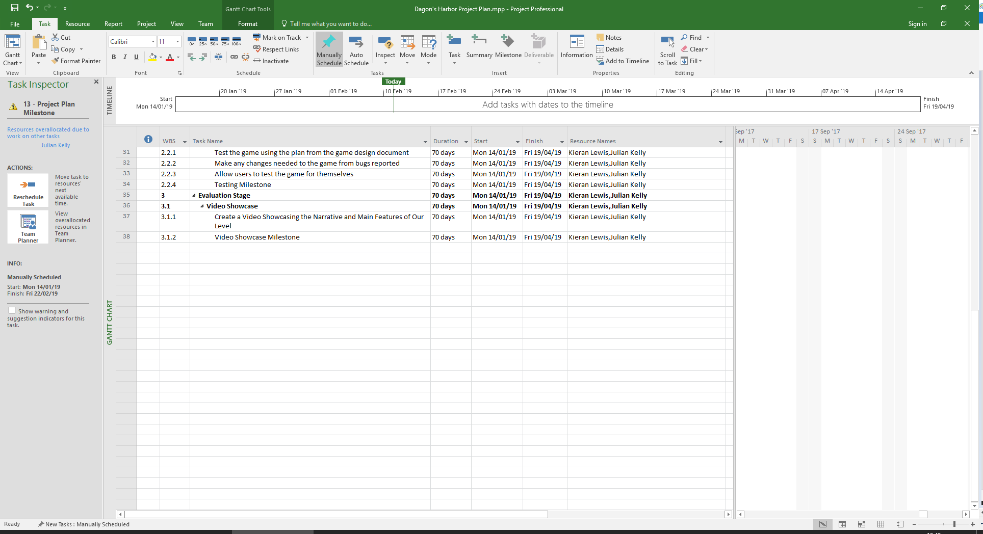

Figure 36 - Gantt chart produced for the project

# Production List

We have created a list of assets that we will be using in the “asset list” heading, however we do not currently have an exact idea of which specific assets will be used for production of the levels.

Some scripts for the game will be written by us during production but we haven’t devised any during the design stage.

We currently do not envisage adding any own made assets due to the time constraints of the project.

# Prop/Asset List

Our Dagon’s Harbor project is facilitated by use of the following middleware and asset collections (or parts thereof)

Terrain Toolkit 2017 middleware

<https://assetstore.unity.com/packages/tools/terrain/terrain-toolkit-2017-83490>

Sun Temple asset collection

<https://assetstore.unity.com/packages/3d/environments/sun-temple-115417>

Flooded Grounds asset collection

<https://assetstore.unity.com/packages/3d/environments/flooded-grounds-48529>

The Wasteland LITE

<https://assetstore.unity.com/packages/3d/environments/fantasy/castle-supply-lite-23699>

Castle Supply LITE

<https://assetstore.unity.com/packages/3d/environments/fantasy/castle-supply-lite-23699>

Ultimate Fantasy Creator LITE

<https://assetstore.unity.com/packages/3d/environments/fantasy/ultimate-fantasy-creator-lite-45579>

Dungeon Creator Kit LITE

<https://assetstore.unity.com/packages/3d/environments/dungeons/dungeon-creator-kit-lite-25575>

Temple Creator LITE

<https://assetstore.unity.com/packages/3d/environments/fantasy/temple-creator-lite-32853>

Pirate Tavern

<https://assetstore.unity.com/packages/3d/environments/fantasy/pirate-tavern-113463>

High Quality Bricks and Walls

<https://assetstore.unity.com/packages/2d/textures-materials/brick/high-quality-bricks-walls-49581>

Modern Zombie Free

<https://assetstore.unity.com/packages/3d/characters/humanoids/modern-zombie-free-58134>

Realistic Effects Pack 4

<https://assetstore.unity.com/packages/vfx/particles/spells/realistic-effects-pack-4-85675>

UFPS: Ultimate FPS

<https://assetstore.unity.com/packages/templates/systems/ufps-ultimate-fps-2943>

Inventory Pro

<https://assetstore.unity.com/packages/tools/gui/inventory-pro-66801>

# Audio Assets

Universal Sound FX

<https://assetstore.unity.com/packages/audio/sound-fx/universal-sound-fx-17256>

Ultimate Game Music Collection

<https://assetstore.unity.com/packages/audio/music/orchestral/ultimate-game-music-collection-37351>

# Playtesting Strategy

For playtesting of the game, we want a lot of people to try out the final levels. We are going to create a small questionnaire which will ask the player how they felt about the environment, the lack of combat and how difficult they found the game.

This will be a few questions on a questionnaire sheet that people can access when they play the game.

There will be some questions that ask some things on a scale of 1 – 5 but then there will be a couple of questions that will ask for a small amount of words on certain areas of the game.

Getting the full opinion on each player understanding how they react to our levels will be the most important parts of the playtesting for us as it will show if our levels are really gripping and allow a good story to be told through playing rather than reading or listening to books or people speaking.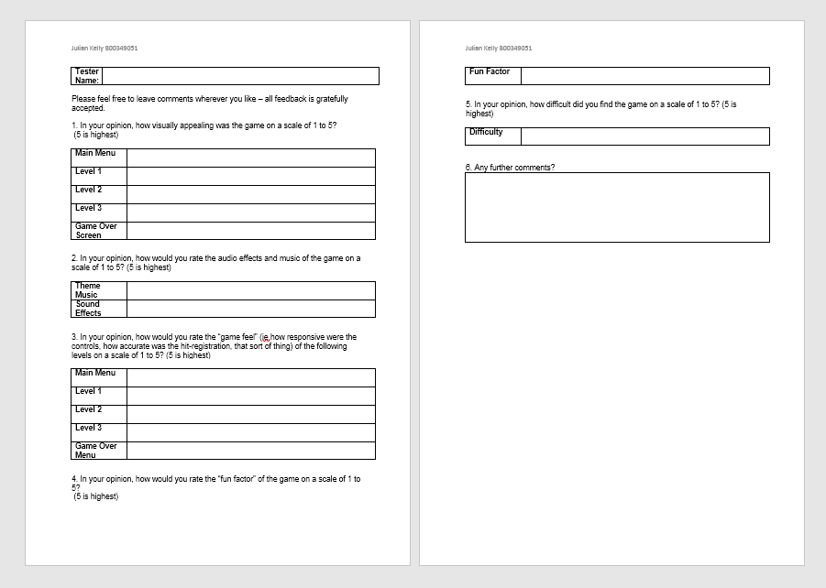

Figure 37 - Example qualitative feedback form

# References

Bui, T., 2010. *Game Design: Linear or Nonlinear.* [Online]   
Available at: https://gamerant.com/game-design-linear-vs-non-linear/  
[Accessed 20 02 2019].

Pruett, C., 2013. *Chris's Survival Horror Quest.* [Online]   
Available at: http://horror.dreamdawn.com/?p=202230  
[Accessed 20 02 2019].

Serr, A., 2009. *Learning from linear level design.* [Online]   
Available at: http://blog.wolfire.com/2009/08/learning-from-linear-level-design/  
[Accessed 20 02 2019].